Quantitative Data Analysis in Research Methodology

What Is Quantitative Data?
Quantitative data refers to information that can be measured and expressed numerically.
It deals with quantities rather than qualities — things you can count, measure, or calculate.
Examples
- Number of visitors on a website
- Temperature readings per day
- Students’ GPA scores
- Likert scale ratings on user satisfaction
Types of Quantitative Data
Type | Description | Example
Discrete data | Countable, whole numbers | Number of students in class (25)
Continuous data | Can take any value within a range | Height (1.65m, 1.72m) or Time spent online (2.5 hrs)
If you survey 200 students on “hours spent studying per week,” you’ll get quantitative data because it’s numerical and measurable.
Key Statistical Terminologies
Term | Explanation | Example
Population | The complete set of individuals or items with a common characteristic | All NSBM undergraduates
Sample | A smaller, representative group taken from the population | 200 students from NSBM
Variable | A measurable characteristic | Age, gender, GPA, satisfaction score
Example
If your population is “Sri Lankan university students,” your sample might be “students from NSBM and SLIIT.”

Branches of Statistics
Branch | Purpose | Example
Descriptive Statistics | Summarize or describe data | Mean GPA, median income
Inferential Statistics | Draw conclusions or predictions about a population using a sample | Predicting job satisfaction using survey results

Descriptive Statistics Example
Average rating for a website = 4.2 / 5
Inferential Statistics Example
Predicting whether age and education level influence satisfaction — using regression analysis.

Descriptive Statistics
a. Measures of Central Tendency
Show where the “center” of data lies.
Measure | Formula / Meaning | Example
Mean (Average) | Total sum ÷ No. of values | (3+4+5+2+6)/5 = 4
Median | Middle value when data is arranged | {2,3,4,5,6} → Median = 4
Mode | Most frequently occurring value | {2,2,3,5,5,5,7} → Mode = 5
Use mean when data is normally distributed, median when there are outliers.

b. Measures of Dispersion
Show how data values are spread out around the mean.
Measure | Meaning | Example
Range | Difference between highest & lowest | 90 – 70 = 20
Variance | Average squared deviation from mean | A measure of data spread
Standard Deviation (SD) | Average distance from mean | High SD → more variation
Example
Two lecturers teach similar classes.
- Class A: Marks 70, 72, 71, 73, 72 → SD = small
- Class B: Marks 50, 65, 80, 95, 100 → SD = large, Class A is more consistent; Class B varies widely.
Measure | Meaning | Result | Interpretation
Mean | Average satisfaction | 4.2 | Students are generally satisfied
Median | Middle value | 4 | Typical response is 4
Mode | Most frequent rating | 5 | Many students rated highest
Standard Deviation | Variation in responses | 0.6 | Responses are quite consistent

Exploratory Data Analysis (EDA)
EDA helps to understand data patterns before deeper analysis.
Type | Focus | Example
Univariate | One variable | Distribution of user satisfaction
Bivariate | Two variables | Age vs. User satisfaction
Multivariate | Three or more | Age, Experience, and Satisfaction

In an LMS study:
- Univariate → Average satisfaction score
- Bivariate → Relationship between gender & satisfaction
- Multivariate → How gender, age, and experience together affect satisfaction

Questionnaire Design and Likert Scales
a. Question Types
Type | Description | Example
Open-ended | Allows free answers | “What do you dislike about the app?”
Closed-ended | Fixed choices or scales | “Rate ease of use (1–5)”
Design Tips
- Start with simple, non-sensitive questions.
- Keep sensitive or difficult questions last.
- Maintain logical flow.
- End with demographic questions (age, gender, etc.).

b. Likert Scales
A scale used to measure opinions and attitudes numerically.
Option | Example
1 | Strongly Disagree
2 | Disagree
3 | Neutral
4 | Agree
5 | Strongly Agree
Example Statement
“The mobile app is easy to navigate.”
Average rating = 4.4 → High satisfaction.
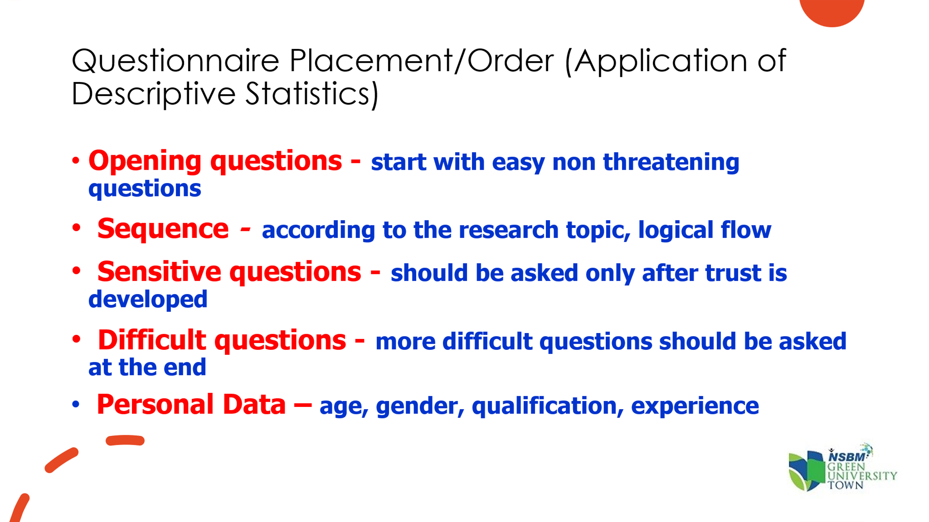
User Experience Questionnaire (UEQ)
A standardized tool for measuring user experience (UX).
Dimensions
- Attractiveness – Is the product appealing?
- Perspicuity – Is it easy to understand?
- Efficiency – Is it fast and responsive?
- Dependability – Is it reliable and secure?
- Stimulation – Is it exciting to use?
- Novelty – Is it innovative or creative?
Example Application
- Conduct UEQ for a university LMS.
- Analyze mean scores for each dimension.
- Identify which areas (e.g., efficiency or stimulation) need improvement.
The User Experience Questionnaire (UEQ) is a standardized tool used to measure the subjective user experience (UX) of an interactive product, such as a website, application, or software system. It helps evaluate how users perceive the product's usability and emotional aspects, providing insights into its strengths and weaknesses.
- User Experience Questionnaire
- Application of UEQ
  - Product Development: To identify areas for improvement in user experience.
  - Benchmarking: To compare user experience across multiple versions or similar products.
  - Usability Testing: To supplement task-based testing with subjective user feedback.
  - Academic Research: To study user experience in technology acceptance and interaction studies.

Inferential Statistics
Descriptive Statistics | Inferential Statistics
Summarize data (what happened) | Test hypotheses or predict (why/what will happen)
Mean, median, mode | Regression, t-test, ANOVA, chi-square
Example: Average satisfaction score = 4.5 | Example: Efficiency significantly predicts satisfaction (p < 0.05)
Used to make predictions or decisions about a population from sample data.
Examples:
- Correlation analysis
- Regression analysis
- Chi-square test
- T-test
Test | What It Does | Data Type | Example
Correlation | Finds strength & direction of relationship | Continuous variables | Study time vs GPA
Regression | Predicts one variable using another | Continuous variables | Efficiency → Usability
Chi-Square | Checks relationship between categories | Categorical data | Gender vs LMS type
T-Test | Compares means of two groups | Continuous data | Before vs After redesign

a. Correlation Analysis
Checks if two variables move together.
Correlation Type | Example | Interpretation
Positive (+) | Study hours ↑ → GPA ↑ | Both rise together
Negative (–) | Age ↑ → Screen time ↓ | One rises, other falls
No correlation (0) | Hair color ↔ GPA | No relationship

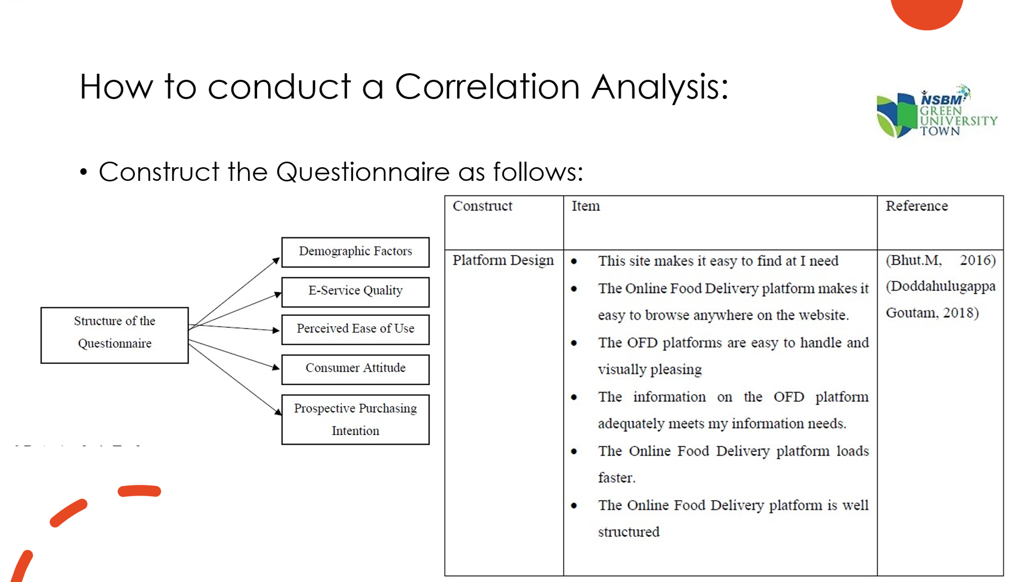
b. Regression Analysis
Predicts one variable (dependent) based on others (independent).
Conducting Regression Analysis
Step | Description | Example
1️⃣ Formulate the hypothesis | Efficiency and attractiveness predict usability | H₁: Efficiency → higher usability
2️⃣ Prepare dataset | Collect UEQ responses and code categorical data | “Male = 0, Female = 1”
3️⃣ Check data quality | Handle missing values, normalize scores | Remove incomplete forms
4️⃣ Conduct descriptive stats | Mean, SD for each variable | Mean efficiency = 5.8
5️⃣ Plot correlation | Check relationships visually | Efficiency ↔ Usability (r = 0.72)
6️⃣ Select regression model | Linear or logistic | Linear for continuous data, Logistic for Yes/No
7️⃣ Perform regression | Using SPSS, R, or Excel
8️⃣ Interpret results | Check coefficients and p-values | p < 0.05 → significant predictor
9️⃣ Validate model | Train/test split or cross-validation
🔟 Apply insights | Suggest system improvements

Example Scenario
Predicting usability score (dependent) based on:
- Efficiency
- Attractiveness
- Dependability
- Stimulation
- Novelty

Example: Interpreting Regression Output conduct on efficiency and usability
Efficiency (β = 0.72, p < 0.05)

Symbol | Meaning
β (Beta coefficient) | Shows the direction and strength of the relationship between the independent variable and the dependent variable.
p-value | Tells whether this relationship is statistically significant (i.e., not due to random chance).

Interpretation ?
- β = 0.72
→ For every 1-unit increase in Efficiency, the Usability Score increases by 0.72 units, assuming all other variables stay constant.
→ This means Efficiency has a strong positive influence on Usability.
- p < 0.05
→ The probability that this relationship happened by random chance is less than 5%.
→ Therefore, this effect is statistically significant.
“When users rate Efficiency higher, their overall Usability score also increases significantly.”
Term | Meaning | What It Tells You
β Coefficient (Beta) | Measures effect size and direction | How much Y changes per unit of X
p-value | Tests statistical significance | Whether the relationship is real or by chance
p < 0.05 | Significant effect | Evidence strong enough to reject the null hypothesis
Positive β | Direct relationship | As X increases, Y increases
Negative β | Inverse relationship | As X increases, Y decreases

c. Chi-Square Test
Used for categorical data to see if variables are related.
Example:
- H₀: Gender and App Preference are independent.
- H₁: Gender and App Preference are related.
If p < 0.05 → Reject H₀ → Relationship exists.
Use Case
Compare “male vs female” preferences for two app versions.

d. Paired Sample T-Test
Used to compare two related groups (before vs after).
Example:
Compare user satisfaction before and after a software update.
If p < 0.05 → There is a significant improvement in satisfaction. p < 0.05 means the result is statistically significant (not by chance).

How to Create a Research Hypothesis
A hypothesis is a statement you test statistically.
It predicts a relationship between two or more variables.
- Identify variables
  - Dependent variable → what you measure (e.g., User Satisfaction)
  - Independent variable → what you test (e.g., Efficiency, Attractiveness)
- Formulate hypotheses
  - Null hypothesis (H₀): No relationship between variables.
Example: “Efficiency does not affect user satisfaction.”
  - Alternative hypothesis (H₁): There is a relationship.
Example: “Efficiency positively affects user satisfaction.”
- Test it using inferential statistics (regression, correlation, t-test, chi-square)
If p < 0.05, reject H₀ → Accept H₁ (relationship exists).
Type | Use Case | Example
Independent T-test | Two separate groups | Compare satisfaction between male vs female students
Paired T-test | Same group measured twice | Compare LMS usability before vs after redesign

Reporting and Interpretation of Results
Reporting
“There was a strong positive correlation between efficiency and user satisfaction (r = 0.81, p < 0.01). Regression analysis indicated that efficiency and attractiveness significantly predicted usability (R² = 0.68).”
- Always include mean, SD, and p-values.
- Use graphs and tables for clarity.
- Discuss what the numbers mean, not just what they are.

Tools for Quantitative Analysis
Tool | Use | Best For
SPSS | GUI-based data analysis | Beginners & surveys
Excel | Quick stats, graphs | Basic calculations
R / Python | Advanced modeling | Researchers, coders
Tableau / Power BI | Data visualization | Reports & dashboards
Minitab | Statistical quality control | Industrial applications

LMS Usability Evaluation
You conduct a survey of 200 university students using the UEQ.
UEQ Dimension | Mean Score | Interpretation
Efficiency | 6.2 | Excellent
Attractiveness | 5.9 | Very Good
Dependability | 4.1 | Needs improvement
Stimulation | 5.5 | Good
Novelty | 4.8 | Moderate

Inference
Students find the LMS efficient and attractive but want better reliability and innovation.

Summary Recap
- Quantitative = Numerical
- Population vs Sample = Entire group vs Subset
- Descriptive statistics summarize data (mean, SD)
- Inferential statistics test hypotheses (correlation, regression, chi-square)
- UEQ and Likert scales measure user experience effectively
- Use tools like Excel, SPSS, R, or Power BI to visualize and report results

